Pre-requistes

1. Begin with the CloudFront distribution pointing to an S3 bucket in place.
2. The CDN URL should be configured as a Cname.
3. The write URL should be configured as a Cname

**Deployment of Networking, Database, and Web Servers**

1. Upload the Cloudformation templates to the rtgstemplatebucket S3 bucket. The RTGS url templates should go in the readytogosurvival folder.
2. Deploy the “rtgsMasterTemplate-First.json” Cloudformation template in the Cloudformation Console. It contains pointers to the other templates in this folder. You will need to choose an SSH Key to attach to web server instance. You can also enter the RDS sign info you’d like here. It is recommended that the default values be changed. The defaults are:
   1. Username – admin
   2. Password – Nn4rd58fNn4rd58f
3. Once the Cloudformation deploys, wait about 10 minutes for all server to become “healthy” at the load balancer.
4. Once healthy, navigate to the web server url. You should see the Wordpress install page.
5. Install wordpress as you normally would by following the on screen wordpress dialogs. This is a temporary install. It will be overwritten by the restore process, but we need to manually activate the All in One plugin that has been pre-installed.
6. Login to wordpress admin page with the credentials you just created.
7. Activate the “All in One Migration” plugin from the plugins page.
8. Use the All in One plugin to import the site backup wpress file
9. Once the backup file uploads you will be prompted to “proceed.” This will give a warning that the database contents will be overwritten. This is desired at this stage, so clicking proceed will start the process.
10. The restore can take up to an hour. Once restored, login to the wordpress admin backend using YOUR site credentials. The temporary credentials created as part of the process above have now been overwritten and are no good.
11. At the point, you should see the site, but the CSS will be broken. This is because nothing is syncing yet to the wp-media-bucket-for-cdn S3 Bucket, so nothing is being served by CloudFront. Once we create the Write Server in the next step, cron will begin the expected syncing to the expected buckets, and CloudFront will ingest properly. Until this sync occurs, the site will be broken.

**Deployment of Write Server**

At this point there will be a working Web Server (broken CSS) and working RDS database. To preserve the workflow, we must create the write server from an image of the now configured Web Server. To do this, we will create an image of the now working Web Server and run the second master Cloudformation template.

1. Login to the EC2 console and select the check mark next to the Web Server
   1. Click “Action” button on top of console
   2. Select image>create image 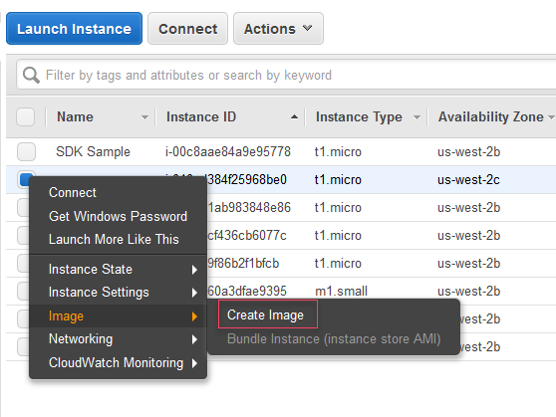
   3. This will open the create image dialog 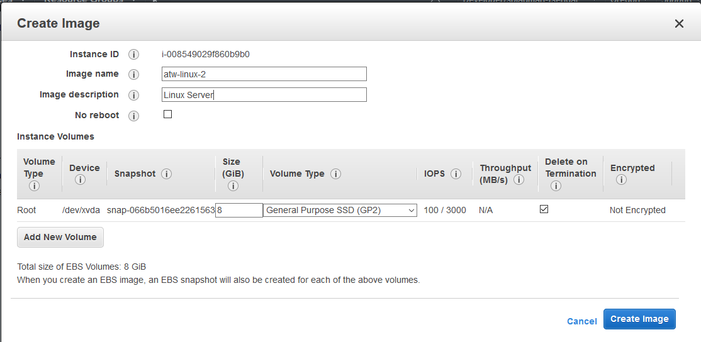
   4. Give the image a logical image name. This particular image will be used temporarily as the image for both Write and Web Servers.
   5. Feel free to give an optional description
   6. !!!!!MAKE SURE YOU CHECK THE NO REBOOT CHECK BOX!!!
      1. Otherwise the server will be stopped for the duration of the image capture
   7. You can leave the “Instance Volumes” section unchanged.
   8. Click “Create Image”
2. Once the image creates, navigate to the rtgstemplatebucket S3 bucket and download “rtgsMasterNestingTemplate-Second.json”. Remember the location you download this template to.
3. Navigate to the EC2 console and choose “AMI’s” from the left menu under the “Images” heading.
4. Collect the AMI-ID of the image that you created in step #1 above.
5. Navigate to the Cloudformation console, and select the check box next to the master template.
6. Click “Actions” and choose “update stack.”
7. Use the “Choose File” Dialog to navigate to the rtgsMasterNestingTemplate-Second.json file downloaded in step 2 and click next.
8. At the bottom of the page under “Other Parameters”, enter the Webserver Image ID and the Write Server Image ID you recorded in step 5. It should be the same image ID for both entries at this point in the process. Also, be sure to visit the “Write Server Configuration” section and select an SSH key for the write server that will be created.
9. Click “Next” and then “Next” again.
10. Click the “I acknowledge” check box and then click “Update.”
11. The new template will deploy a new Launch Configuration for the Web Server, with an image that now has Wordpress baked in. It will also create all needed infrastructure for the Write Server.
12. Once the Write Server creates and becomes healthy, it will begin syncing via cron. It will sync the code to the wp-code-backup S3 bucket and will sync the uploads folder to the wp-media-bucket-for-cdn S3 bucket.
13. Terminate the running Web Server so that a new Web Server is launched from the newly deployed Launch configuration. This will launch a production ready Web Server.

**Post Launch**

After running the second master template, we will have working web servers and a write server with Apache, Wordpress, and the site installed and configured to work correctly. However, we will need to take one last step to finish configuring the User Data section on the Write Server for ongoing use.

1. Return to the “**Deployment of Write Server”** section above and follow the steps to create an image. Only this time, create an image of the newly launched write server and record the image ID.
2. Once the image creates, navigate to the rtgstemplatebucket S3 bucket and download “rtgsMasterNestingTemplate-post-launch.json”. Remember the location you download this template to.
3. Navigate to the Cloudformation console, and select the check box next to the master template.
4. Click “Actions” and choose “update stack.”
5. Use the “Choose File” Dialog to navigate to the rtgsMasterNestingTemplate-post-launch.json file downloaded in step 2 and click next.
6. At the bottom of the page under “Other Parameters”, change the Write Server Image ID to the ID of the write server image you just captured. At this step, the Web Server and Write Server image ID’s should be different. The Web Server ID is the ID of the image that was captured in the first pass through the “Deployment of Write Server” section above. The Write Server ID is the image ID you just created.
7. Click “Next” and then “Next” again.
8. Click the “I acknowledge” check box and then click “Update.”
9. This will update the Write Server Launch Configuration to a production state for continued use.
10. Once the CloudFormation updates, terminate the Write Server. A new one will be launched that will be in a production state for ongoing use.